Manchester Wildcatz - Cheadle Venue Guide
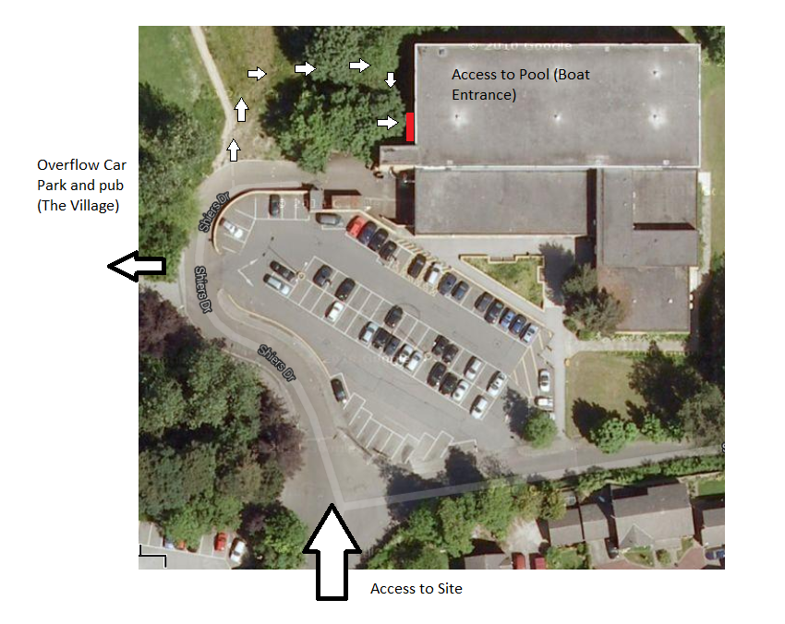
TAKE SHOES OFF UPON ENTERING THE POOL
Setting UP Goals
- The goals are stored in the Plant room entrance, accessed via the medical room which is on your immediate right when entering the pool via the boat entrance (you may need to ask a lifeguard for access as its sometimes locked)
- Ensure the goals are set up at the correct end, there’s a karabiner attached to each window end of rope, these are clipped onto the hanging rope on the window wall side of the pool. Throw the other end up to the balcony.
- The balcony is accessed via a door in the far right corner (past the small pool). Simply tie down the rope to the furthest back banister rail when the right height is attained.
- The goal rope that’s set up by the glass window end/boat entrance needs to navigate past the goal cover. Ensure the rope passes IN- FRONT of both stands and that it doesn’t get caught on the cover USE a PADDLE to ensure it DOESN’T GET CAUGHT.
- VERY IMPORTANT - Ensure the large safety net is pulled across the windows and secured at both ends. (Can be clipped around the pool line reel on the right and secured using pool brick weights on the left)
- On Take down – Do not remove karabiners or the rope and hang the goals back up in the Plant room entranceway. If locked leave in the Medical room.

